# Design Overview for Student Attendance System

Name: Dao Khanh Nga Thi

Student ID: 104177393

# Summary of Program

The "Student Attendance System" is a tool for organizing student data and managing the attendance process. The MySQL database will be used to hold student data such as personal information, class information, and attendance statistics. Users can access administrative functions like update and deletion after logging in to connect to the database. In order to build an interface through which users can alter information by filling out forms and clicking on buttons, window forms are also used. A sample output drawing is provided below to help explain the concept:

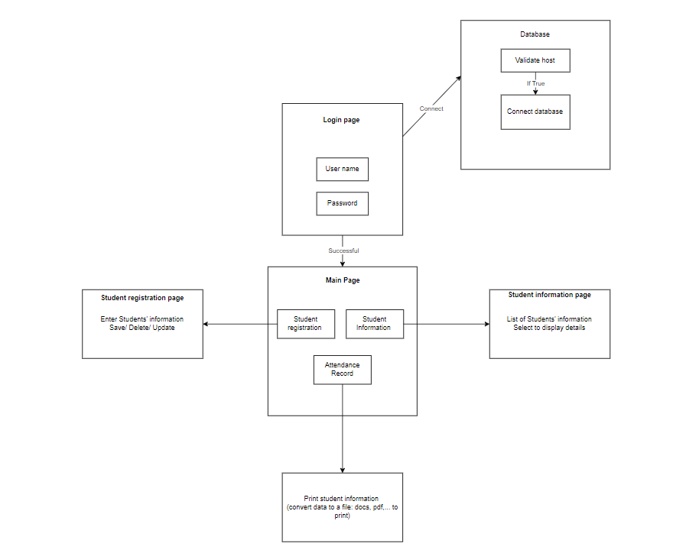

# Required Roles

Describe each of the classes, interfaces, and any enumerations you will create. Use a different table to describe each role you will have, using the following table templates.

Table : <<role name>> details – duplicate

|  |  |  |
| --- | --- | --- |
| Responsibility | Type Details | Notes |
|  | Field type, parameter and return types |  |
| Form | Attendance, login, homepage, registration form, student information. | These pages will be developed; however, there may be other pages |
| Field | Student information (name, id, …), username, password, class | These fields are the collection of input, username and password are not used for validate but also to connect database. |
| Record | List, selected from database | Display on the student information page for the convenience of updating data |
| Button | Save, update, delete |  |
| Time | Day, hour | Will be display on the page interface and also a record data of the time students took attendance. |
| Picture | Students’ image, QR code | Each student will be provided an image and an QR code for the authentication issue |
| Scan QR | Capture device, camera | Maybe develop later if there are available references |
| Printer | Not sure | Maybe develop later if there are available references. |
| Layout | Size, font, colours, position, button | Included when creating interface. |
| Interface | Window form |  |
| Database | MySQL |  |

# Class Diagram

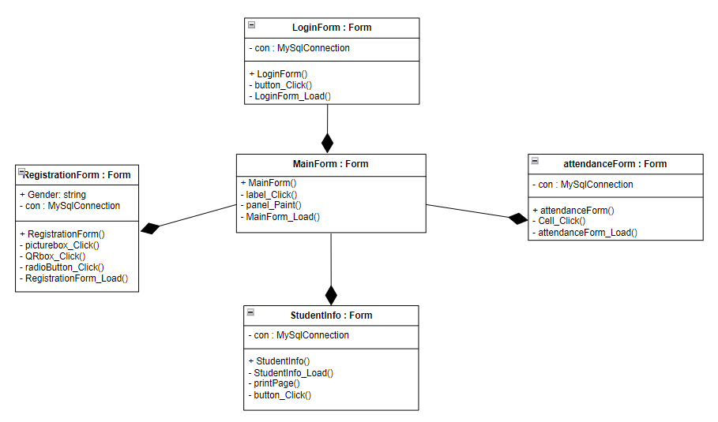

# Sequence Diagram

